Technical Architecture:

Project Design Phase-II Technology Stack (Architecture & Stack)

|  |  |
| --- | --- |
| Date | 16 October 2022 |
| Team ID | PNT2022TMID14744 |
| Project Name | Real Time River Water Monitoring and Control  Systems |
| Maximum Marks | 4 Marks |

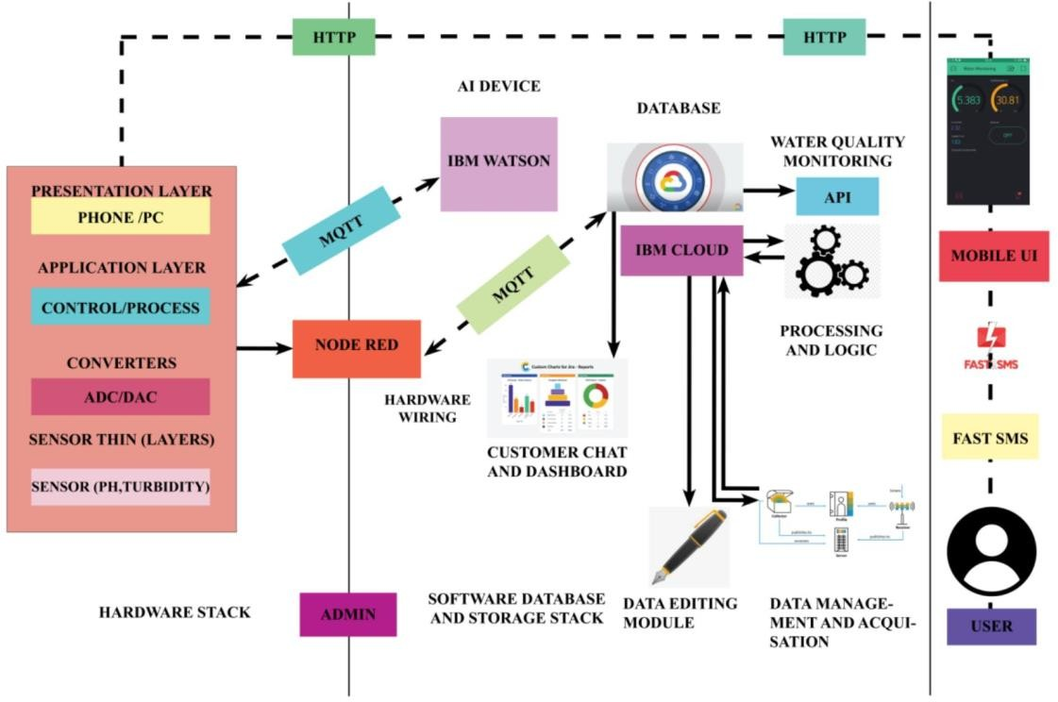

Table-1 : Components & Technologies:

|  |  |  |  |
| --- | --- | --- | --- |
| **S.No** | **Component** | **Description** | **Technology** |
| 1. | User Interface | Mobile UI | HTML, CSS, java script |
| 2. | Application Logic-1(mobile application) | Scale meter is introduced to monitor the water parameters | Java |
| 3. | Application Logic-2(AI Application) | For predicting future values of water quality range | IBM Watson Assistant |
| 4. | Database | Data Type | NOSQL. |
| 5. | Cloud Database | Database Service on Cloud | IBM Cloudant |
| 6. | File Storage | File storage requirements:  Container Platform Version 4.6 | IBM Block Storage |
| 7. | External API-1 | The data is used to compare the values for sensor with threshold values | IBM water quality API |
| 8. | External API-2 | For the locals and authorities to know the water quality | mobile API, |
| 9. | Machine Learning Model(node-red) | For interfacing hardware and software application(a virtual wiring tool) | Platform:  Node.js |
| 10. | Infrastructure (Server / Cloud) | Application Deployment on cloud  Cloud Server Configuration : application-client-bnd | IBM cloud |

Table-2: Application Characteristics:

|  |  |  |  |
| --- | --- | --- | --- |
| **S.No** | **Characteristics** | **Description** | **Technology** |
| 1. | Open-Source Frameworks | [Bootstrap](https://github.com/twbs/bootstrap) | CSS |
| 2. | Security Implementations | MQTT,CoAP,DTLS,6LoWPAN | Encryptions, OWASP |
| 3. | Scalable Architecture | The scalability of architecture (3 – tier) | IOT and mobile application |
| 4. | Availability | Distributed servers | IBM cloud and Watson |
| 5. | Performance | Use of cache,better performance | Fast SMS application |